Name_________________________
1.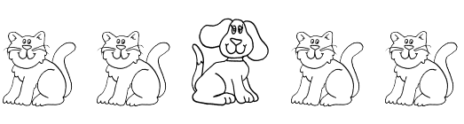
________________________________________
2.


________________________________________
3.

________________________________________

4.

__________________________________________
5.

__________________________________________

6.
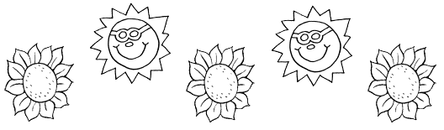

__________________________________________

Challenge!
7.


__________________________________________

